PF LAB 4 TASKS

TASK 4:
#include<stdio.h>

main()
{
int score;
printf("enter your score: ");
scanf("%i" , &score);
if (score >= 90){
printf("your grade is : A");
}
else if ((score >= 80) && (score <= 89)){
printf("your grade is : B");
}
else if ((score >= 70) && (score <= 79)){
printf("your grade is : C");
}
else if ((score >=60) && (score <=69)){
printf("your grade is : D");
}
else{
printf("your grade is: F");
}
}
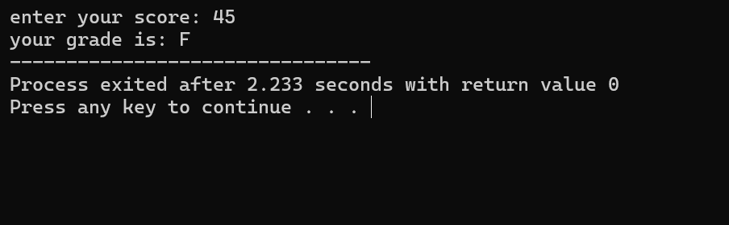

TASK 5:
#include<stdio.h>

main()
{
int userinput;
printf("enter the colour light\n1 for red\n2 for yellow\n3 for green\n");
scanf("%i" , &userinput);
switch(userinput){
case 1:
printf("Stop");
break;

case 2:
printf("Ready");
break;
case 3:
printf("Go");
break;
default:
printf("invalid input");
}
}
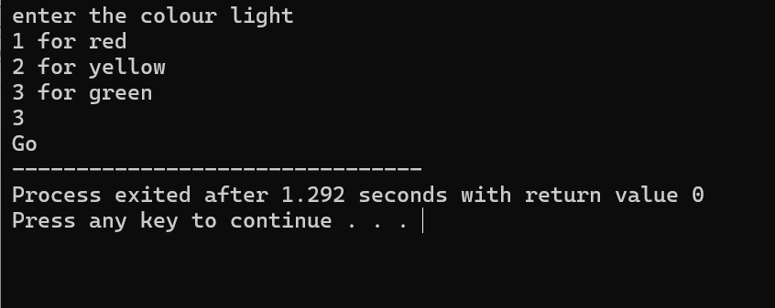

TASK 6:
#include <stdio.h>
main() {
float num1, num2;
char op;
float result;

printf("Enter number 1: ");
scanf("%f", &num1);

printf("Enter number 2: ");
scanf("%f", &num2);

printf("Enter your operator (+, -, *, /): ");
scanf(" %c", &op);

switch (op){
case '+':
result = num1 + num2;
printf("result: %.2f",result);
break;
case'-':
result = num1 - num2;
printf("result: %.2f", result);
break;
case '/':
if (num2 == 0){
printf("division not possible");
}
else {
result = num1/num2;
printf("result: %.2f" , result);
}
break;
case '*':
result = num1 * num2;
printf("result: %.2f" , result);
break;
default:
printf("Invalid operator!\n");
}

}
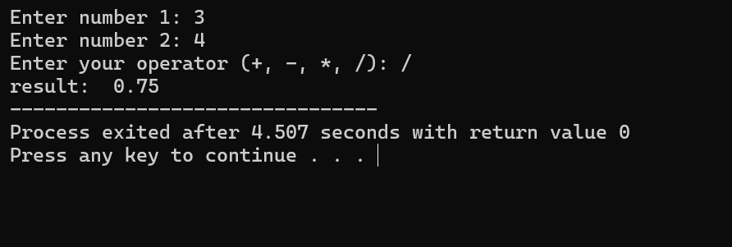

TASK 7:
#include<stdio.h>

main()
{
int year;
printf("enter year: ");
scanf("%i" , &year);
if ((year%4==0) && (year%100!=0)){
printf("year is a leap year");
}
else{
printf("year is not a leap year");
}
}
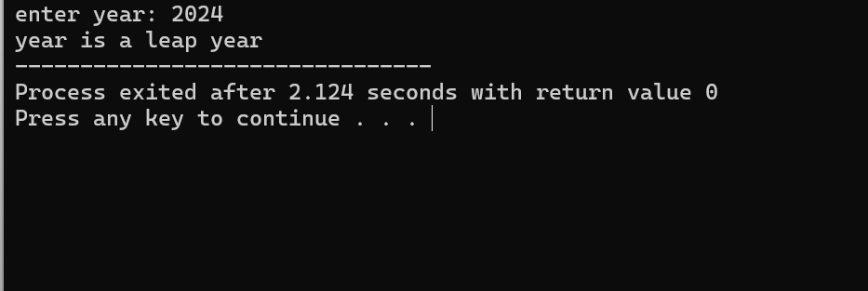

TASK 8:
#include<stdio.h>

main()
{
int num;
printf("enter your number: ");
scanf("%i",&num);
if (num > 0){
printf("number is positive");
}
else if (num < 0){
printf("number is negative");
}
else if (num == 0){
printf("num is 0");
}
}
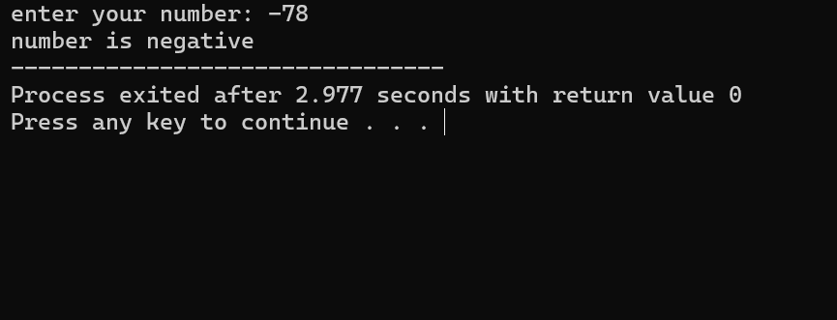

TASK 9:
#include <stdio.h>

main() {
int daynumber;
printf("enter the day number: ");
scanf("%i" , &daynumber);
switch (daynumber){
case 1:
printf("monday");
break;
case 2:
printf("tuesday");
break;
case 3:
printf("wednesday");
break;
case 4:
printf("thursday");
break;
case 5:
printf("friday");
break;
case 6:
printf("saturday");
break;
case 7:
printf("sunday");
break;
default:
printf("invalid input");

}

}
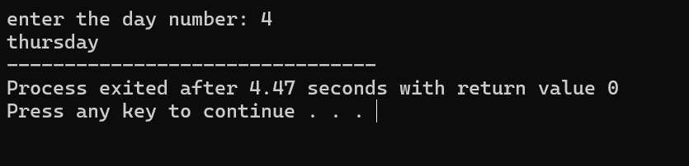

TASK 10:
#include<stdio.h>

main()
{
int password = 1234;
int userinput;
printf("enter the password: ");
scanf("%i" , &userinput);
if (userinput == password){
printf("access granted");
}
else{
printf("access denied");
}
}
